Fashion and Ethnicity

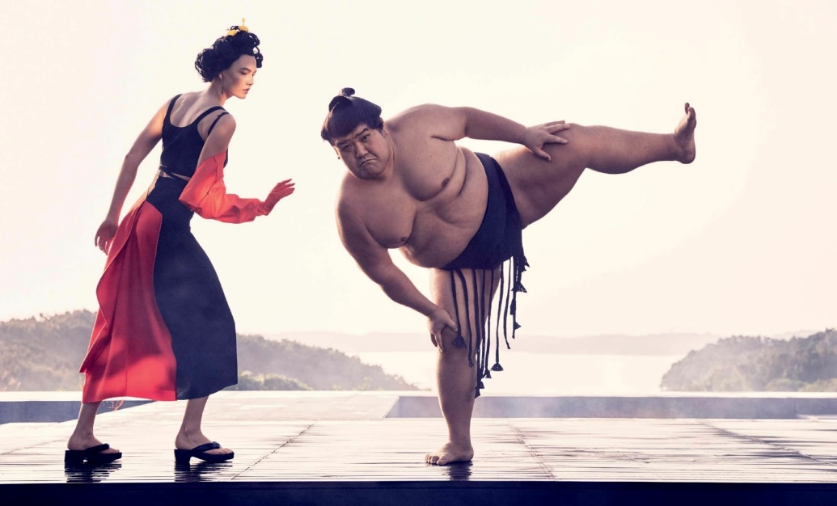
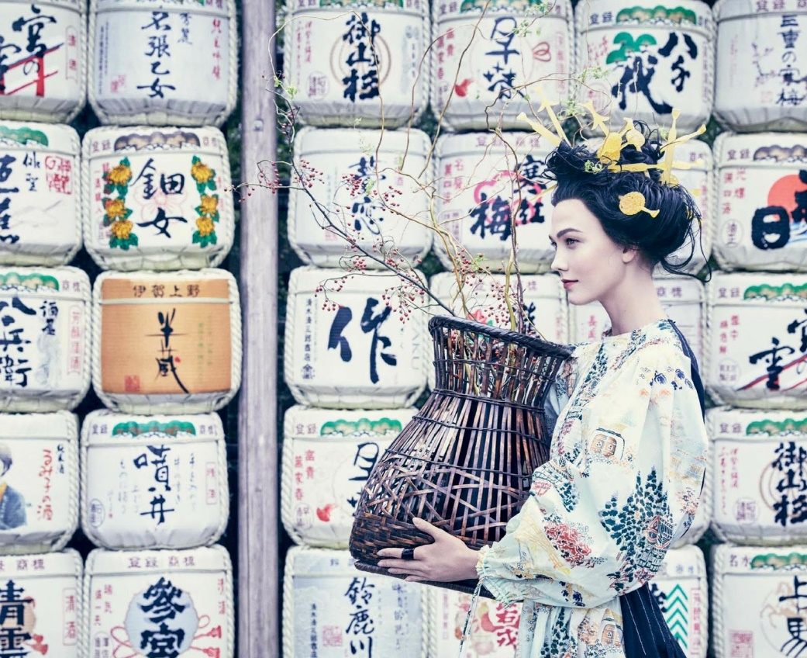
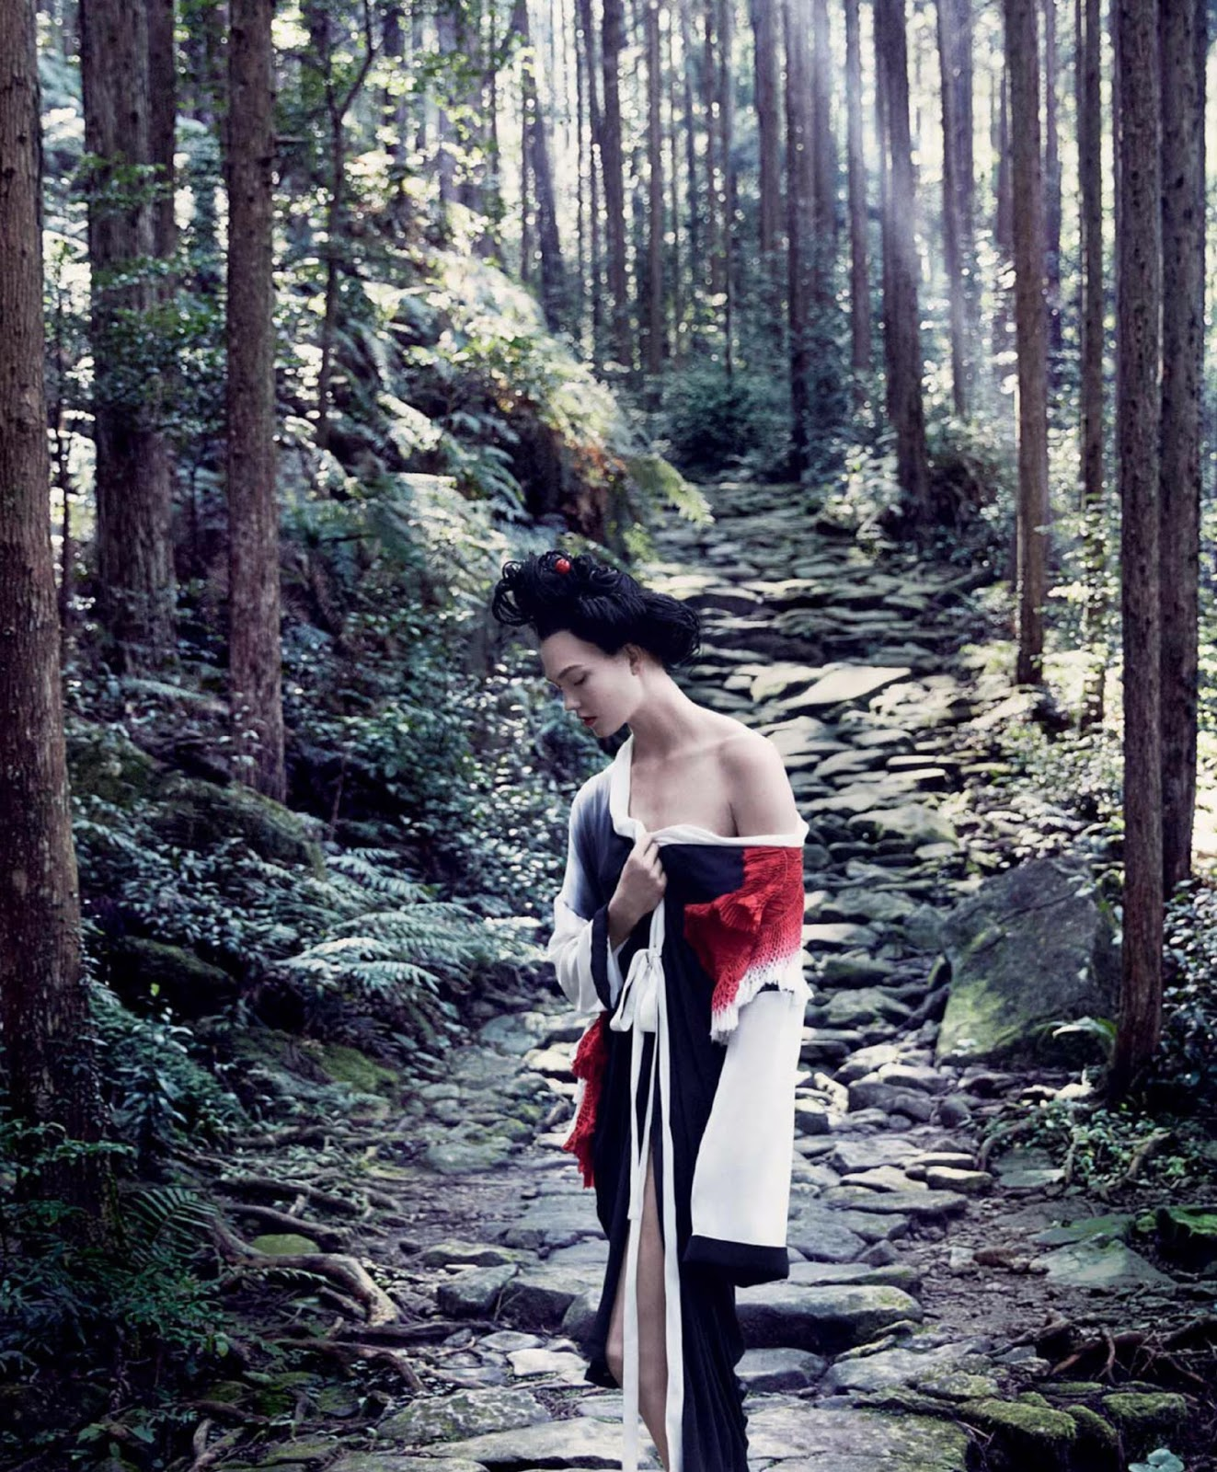

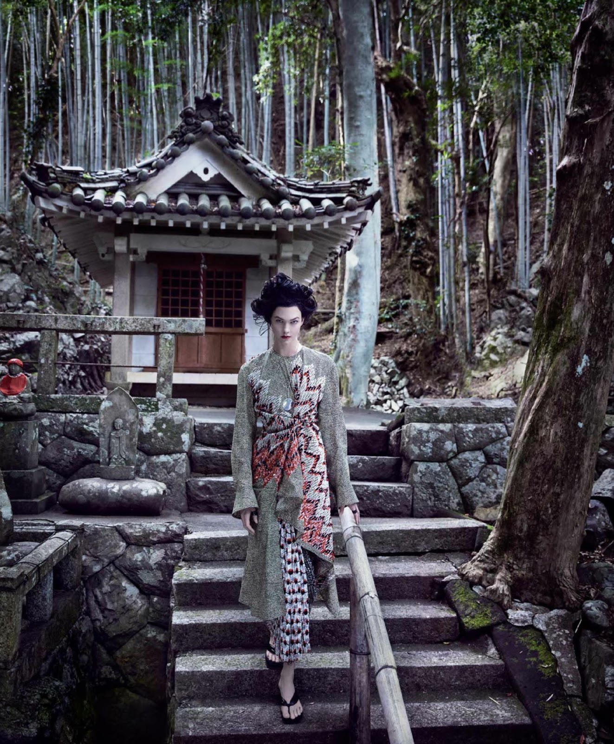

These pictures, taken in a national park in Japan, are the ones used in Vogue US March 2017.
On the article with the title of “Spirited Away,” Karlie Kloss, a white-American model, is modelling as a Japanese geisha (photography: Mikael Jansson, style: Phyllis Ponsnick).
This is not even a tokenism.

Location is Japan, a Sumo wrestler in one of the photo is Japanese, props and clothes are Japanese-based, but…
Why model is not Japanese?

The pictures circulated online provoked many criticisms as “cultural appropriation” or “yellowface.” Some also criticized this as a part of misconception that features Japanese / Asian women as overly sexualized image.
The criticism was so huge that Karlie Kloss apologized on Twitter about the shooting, recognizing cultural appropriation.

The pictures gave me an impression that culture is being depicted as “other world” outside Western, which adds some exotic spice to fashion, but for producers in fashion industry, people of racial group in that culture are “not good enough,” “not beautiful enough,” “not Western enough,” or whatever reason, to represent fashion.

This kind of issue is correlated to whitewash in Hollywood films, such as ‘Ghost in the Shell’ in which Caucasian actress played an Asian role.

In fashion media as well as film, protagonists predominantly tend to be Western, even though there are many quality non-white models (/actors).
Regardless of huge movement of Asian representation in media, the issue of Vogue pictures show that still fashion industry remains highly racism, or racial insensitive world.

